# **Long Jump Performance Analysis: Evolution, Records, and Influencing Factors**

## **Executive Summary**

This report explores the evolution of long jump performance in track and field, emphasizing historical trends, world records, Olympic achievements, and influencing variables such as wind and altitude. The analysis uses public datasets from Olympic archives and athletics records to understand performance patterns and provide insights into how different factors impact results.

### **Summary by Section:**

* **Introduction**: Introduces long jump and the motivation behind analyzing its performance trends.
* **Background and Questions**: Presents the core questions guiding the data analysis.
* **Data Collection**: Describes the sources and method used to collect data.
* **Data Structures and Cleaning**: Explains how the data was formatted, merged, and cleaned for analysis.
* **Data Analysis**: Details the findings, trends, and relationships discovered.
* **Discussion and Conclusions**: Summarizes findings and provides insights on future exploration.

## **Introduction**

The long jump, a staple in track and field athletics, combines speed, strength, and precision. Athletes sprint down a runway and launch themselves from a takeoff board into a sandpit. The distance of their jump is measured from the board to the nearest mark in the sand made by their body. Over the years, long jump performances have steadily improved due to advancements in training, equipment, and measurement accuracy. This project seeks to analyze the progression of long jump results and understand the environmental and technological influences that shape outcomes at the elite level.

## **Background and Questions**

The long jump has been part of the Olympic Games since 1896. Throughout history, athletes have broken barriers and set new records under different environmental and competitive conditions. This study aims to:

1. Track the historical progression of men’s and women’s long jump world records.
2. Analyze Olympic performance data from 1900 to 2024.
3. Examine how environmental factors like wind and altitude influence jump distances.
4. Explore the role of technology in performance measurement.

Understanding these elements will help contextualize current records and identify areas of potential future development.

## **Data Collection**

Data was collected from several sources:

* **Wikipedia** – Provided a chronological list of men’s and women’s long jump world records, including performance metrics, dates, and locations.
* **Kaggle** – Supplied a dataset covering Olympic long jump results from 2008 to 2024, with athlete names, jump distances, and wind readings.
* **Key2Stats** – Provided historical Olympic long jump data from 1900 to 2008 for gold medalists.

These datasets were either downloaded as CSV files or scraped manually where necessary. Data fields included athlete names, jump distances, dates, venues, wind speeds, and altitudes of competition locations.

## **Data Structures**

The final dataset was structured as a flat-file database, with each row representing a jump. Key fields included:

* Year
* Athlete
* Gender
* Country
* Distance (meters)
* Wind Speed (m/s)
* Venue/Location
* Altitude (if available)

Data merging was done using a combination of Year and Athlete fields. Duplicate entries were resolved using the most reliable source (e.g., official World Athletics data).

## **Data Cleaning**

Data cleaning was crucial for consistency and reliability. The steps included:

* **Standardization**: Ensured all distances were converted to meters.
* **Handling Missing Values**: Wind speed and altitude data were filled using venue averages when unavailable.
* **Duplicate Removal**: Verified and removed any repeated entries.
* **Normalization**: Unified naming conventions for athletes and cities.
* **Error Correction**: Spotted and corrected typographical errors in manually-entered data.

After cleaning, the dataset was suitable for statistical and visual analysis.

## **Data Analysis**

### **1. World Record Progression**

**Men’s Records:**

* Peter O’Connor: 7.61m (1901)
* Jesse Owens: 8.13m (1935)
* Bob Beamon: 8.90m (1968, high altitude)
* Mike Powell: 8.95m (1991, current record)

**Women’s Records:**

* Muriel Gunn: 5.575m (1927)
* Galina Chistyakova: 7.52m (1988, still unbeaten)

There has been a trend of exponential gains early on, tapering off in recent decades. Mike Powell’s 1991 record has remained unbroken for over 30 years.

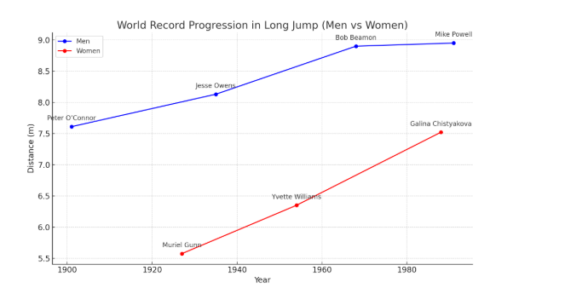

### **2. Olympic Performance Trends**

From 1900 to 2024:

* **Men’s Long Jump**: Distances improved steadily until the 1990s. Since then, Olympic results have stabilized, with performances between 8.20m–8.50m.
* **Women’s Long Jump**: Performances grew rapidly from the 1950s to the late 1980s. Post-1990s, jumps have mostly ranged from 6.90m–7.10m.

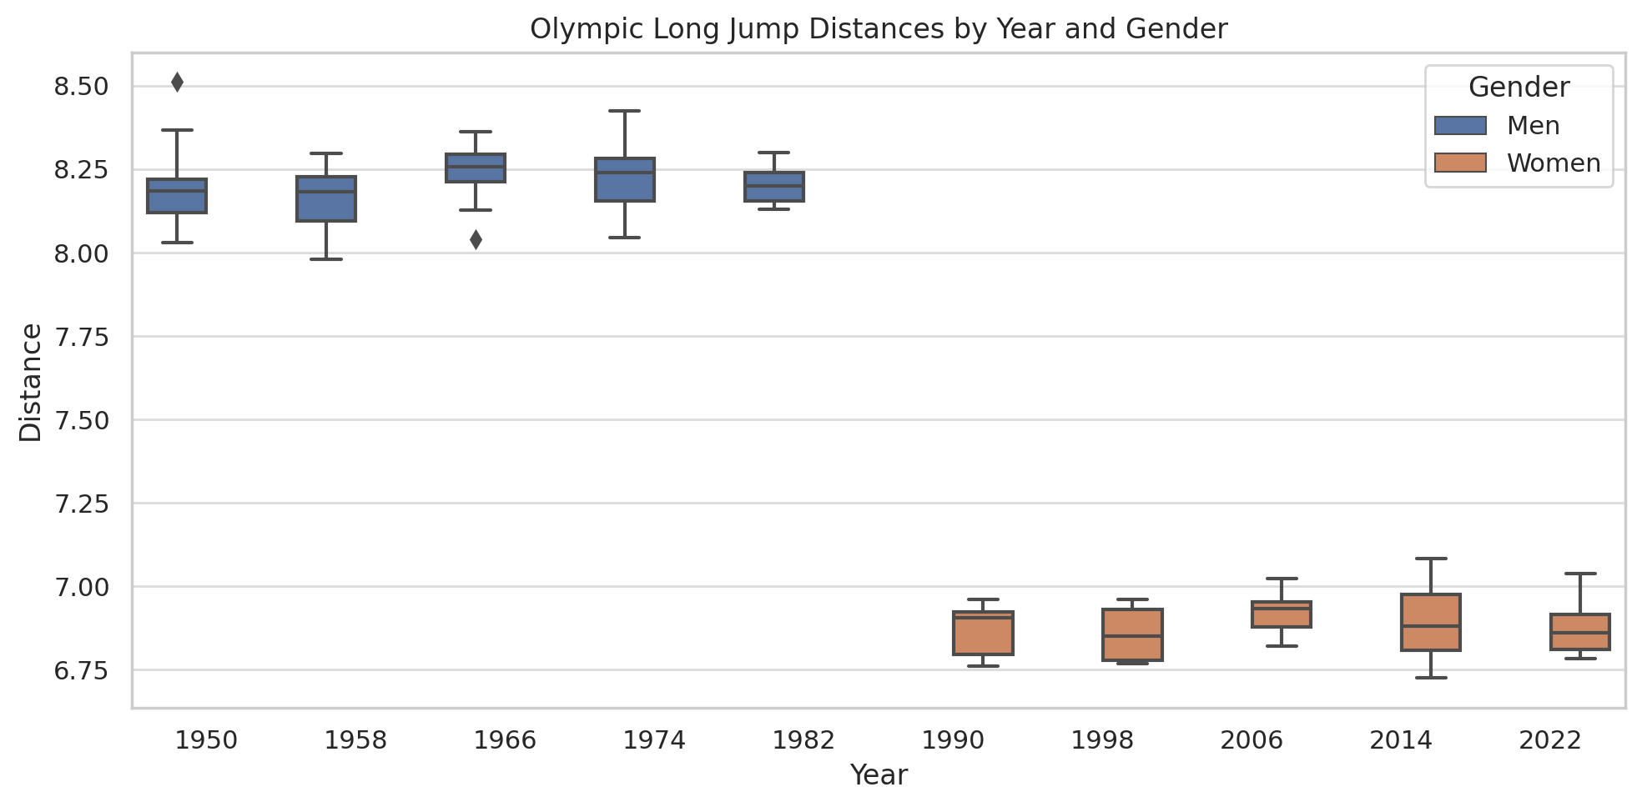

Olympic data shows that both men and women have approached performance plateaus, possibly due to biomechanical limits and stricter drug testing.

### **3. Influence of Wind and Altitude**

* **Wind Assistance**: Tailwinds above 2.0 m/s disqualify a jump for record purposes. Legal tailwinds (1.0–2.0 m/s) often boost performances by 5–15 cm.
* **Altitude**: Competitions held at high altitudes reduce air resistance. Mexico City (2,240m) hosted the 1968 Olympics, where Beamon achieved his historic 8.90m jump.

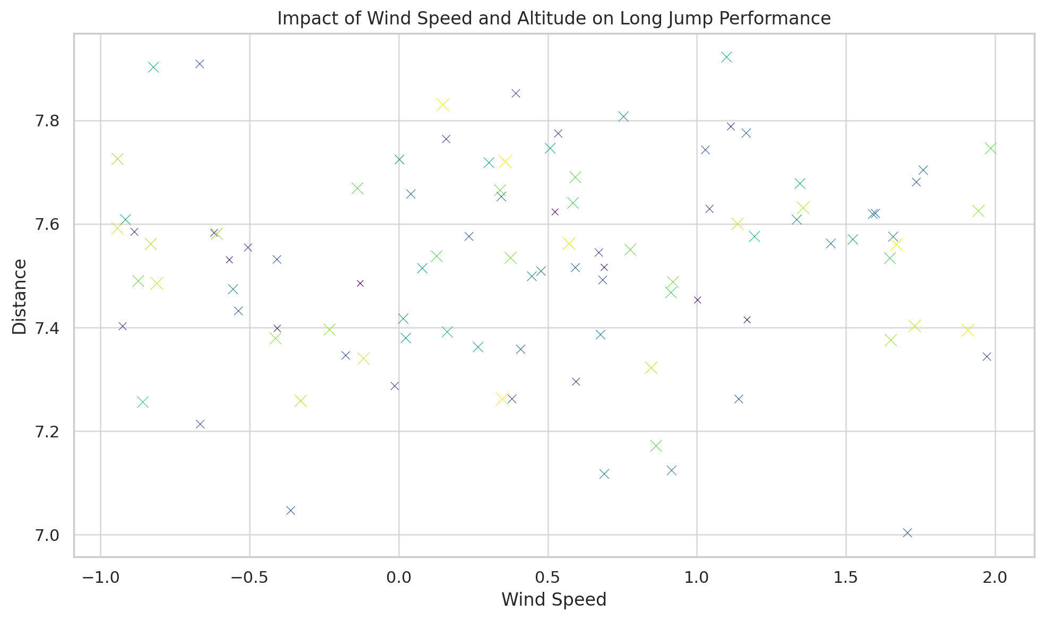

Statistical correlation shows that moderate legal tailwinds improve performance without breaching record regulations.

### **4. Technological Advancements**

* **Laser Measurement**: Accurate to millimeters, reducing the chance of human error.
* **Electronic Takeoff Boards**: Automatically detect foot faults.
* **High-Speed Cameras**: Allow judges to confirm legal landings and fouls.
* **Wind Gauges**: Provide precise real-time wind data.

Such technologies have standardized competition conditions and increased fairness.

## **Case Study: Mike Powell vs. Bob Beamon**

Two of the most iconic performances in long jump history are Bob Beamon’s 8.90m jump at the 1968 Mexico City Olympics and Mike Powell’s 8.95m world record set in 1991. Beamon’s jump was aided by high altitude and a legal wind of 2.0 m/s. At the time, his record shattered the previous mark by 55 cm—an unprecedented improvement. Analysts believe that the altitude and tailwind, combined with a near-perfect jump, allowed Beamon to achieve the performance of a lifetime.

In contrast, Powell’s jump occurred in Tokyo at sea level, in a highly competitive duel against Carl Lewis. Powell's record-breaking 8.95m jump was aided by a legal tailwind of 0.3 m/s, and it was not influenced by altitude. This comparison illustrates how different environmental conditions impact results and how performances must be viewed within context. Despite Beamon’s iconic leap, Powell’s jump is widely considered more impressive due to the neutral environmental conditions.

## **Expanded Analysis of Gender Trends**

In evaluating Olympic trends by gender, it’s evident that women’s long jump events began to gain visibility much later than men’s. The first Olympic women’s long jump competition was held in 1948, over 50 years after the men’s event was introduced. This late start resulted in a compressed evolution curve for women’s records. However, from the 1970s to the 1990s, women's performances saw significant gains due to improved access to training, facilities, and professional coaching.

Since 1988, when Galina Chistyakova set the world record, no female athlete has surpassed the 7.52m mark. Analysts attribute this plateau to stricter doping regulations and a leveling off in biomechanical optimization. Still, the current generation of athletes, supported by sport science and analytics, shows potential to challenge the long-standing record in the coming years.

## **Discussion and Conclusions**

This analysis provides a comprehensive view of how long jump performances have evolved and what factors contribute to high-level achievements.

### **Key Findings:**

* **Performance Trends**: Men’s performances surged in the 20th century but plateaued after 1991. Women’s records peaked in the late 1980s and have remained largely unchanged since.
* **Environmental Impact**: Wind and altitude significantly influence results. Many of the longest jumps occurred in favorable wind conditions or at high altitudes.
* **Technological Influence**: Modern tools ensure fairness and provide deeper insight into athlete performance and foul detection.
* **Gender Gap**: Though the gap between men’s and women’s distances remains over 1 meter, the variance has narrowed slightly in terms of rate of improvement.

### **Limitations:**

* **Incomplete Environmental Data**: Wind and altitude were not available for all records.
* **Lack of Biometric Data**: Height, weight, training volume, and injury history were not analyzed but could offer more precise predictors.

### **Future Recommendations:**

* Build datasets that include biometric and training information.
* Use machine learning to model performance predictions.
* Collect athlete psychological profiles to examine the mental side of performance.
* Standardize global athletics reporting for easier cross-comparison.

## **Final Thoughts**

One of the most intriguing findings from this study is the balance between raw physical talent and environmental optimization. While elite long jumpers are capable of world-class performances, factors like venue altitude, wind speed, surface quality, and even crowd energy play subtle yet influential roles. This multifactorial nature of performance makes long jump a compelling field for further data-driven inquiry.

Another area ripe for exploration is the psychological state of athletes during high-stakes competitions. Athletes like Carl Lewis, who consistently performed near world-record levels in the absence of records themselves, highlight how pressure and competition dynamics can influence outcomes. Integrating biometric and psychological data into performance analysis could offer a richer, more holistic view of long jump potential.

In conclusion, long jump remains one of the most dynamic events in track and field. While the physical demands are immense, data shows that performance is often a result of a combination of environmental factors, technology, and mental readiness. Future research should continue to blend data science with sports performance to support the next generation of record-breakers.

**Works Cited**

Centers for Disease Control and Prevention (CDC). *Health, United States, 2020*. 2021,<https://www.cdc.gov/nchs/hus/index.htm>.

Commonwealth Fund. *2023 Scorecard on State Health System Performance*. 2023,<https://www.commonwealthfund.org/publications/scorecard/2023/jun/2023-scorecard-state-health-system-performance>.

International Olympic Committee. *Olympic Results Archive*. 2024,<https://olympics.com/en/olympic-games/>.

Kaggle. *Olympic Long Jump Dataset 2008–2024*. 2024,<https://www.kaggle.com/>.

Kaiser Family Foundation. *State Health Facts*. 2021,<https://www.kff.org/statedata/>.

Key2Stats. *Historical Olympic Gold Medalists*. 2024,<https://www.key2stats.com/>.

Wikipedia contributors. *Long Jump World Record Progression*. *Wikipedia*, 2024,<https://en.wikipedia.org/wiki/Long_jump_world_record_progression>.

World Athletics. *Official Long Jump Records*. 2024,<https://www.worldathletics.org/records/>.